Space News Update – August 2015
By Pat Williams
IN THIS EDITION:
- Rosetta's big day in the sun.
- Nitrogen provision in Pluto’s atmosphere.
- Gaia's first year of scientific observations.
- New Horizons team selects potential Kuiper Belt flyby target.
- Magnetically driven resonance helps heat the Sun’s atmosphere.
- Age of deep-space exploration with CubeSats heralded.
- ESO and ESA Directors General sign cooperation agreement.
- Links to other space and astronomy news published in August 2015.
Disclaimer - I claim no authorship for the printed material; except where noted.

ROSETTA'S BIG DAY IN THE SUN.

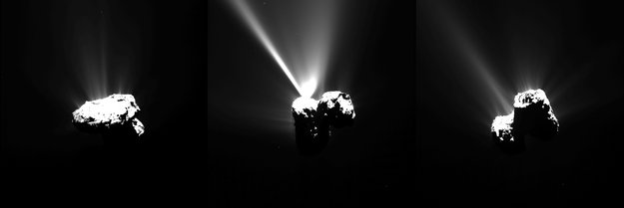Approaching perihelion Credit: ESA

ESA’s Rosetta witnessed Comet 67P/Churyumov–Gerasimenko making its closest approach to the Sun. The exact moment of perihelion occurred at 02:03 GMT on the morning of 13 August 2015 when the comet came within 186 million km of the Sun. In the year that has passed since Rosetta arrived, the comet has travelled some 750 million kilometres along its orbit towards the Sun, the increasing solar radiation heating up the nucleus and causing its frozen ices to escape as gas and stream out into space at an ever greater rate. These gases, and the dust particles that they drag along, build up the comet’s atmosphere – coma – and tail. Rosetta’s measurements suggest the comet is spewing up to 300 kg of water vapour – roughly the equivalent of two bathtubs – every second. This is a thousand times more than was observed this time last year when Rosetta first approached the comet. Then, it recorded an outflow rate of just 300 g per second, equivalent to two small glasses of water. Along with gas, the nucleus is also estimated to be shedding up to 1000 kg of dust per second, creating dangerous working conditions for Rosetta. Rosetta is far too close to the comet to see its growing tail, but images collected over the past few months with telescopes across the world show that it already extends more than 120 000 km.
Rosetta's big day in the sun (13 August 2015)

Comet's firework display ahead of perihelion (11 August 2015)
In the approach to perihelion over the past few weeks, Rosetta has been witnessing growing activity from Comet 67P/Churyumov–Gerasimenko, with one dramatic outburst event proving so powerful that it even pushed away the incoming solar wind.

NITROGEN PROVISION IN PLUTO’S ATMOSPHERE.

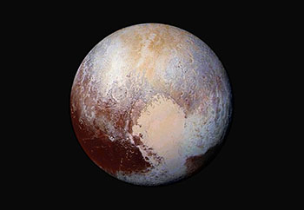
Image Courtesy of NASA/JHUAPL/SwRI
The latest data from NASA’s New Horizons spacecraft reveal diverse features on Pluto’s surface and an atmosphere dominated by nitrogen gas. Scientists at Southwest Research Institute are studying New Horizons data to discover what’s pumping up the nitrogen in Pluto’s atmosphere, even as it escapes into interplanetary space. This enhanced colour image of the dwarf planet helps scientists detect differences in the composition and texture of Pluto’s surface. The data hint that Pluto may still be geologically active, a theory that could explain how Pluto’s escaping atmosphere remains flush with nitrogen. Nitrogen provision in Pluto’s atmosphere (11 August 2015)

GAIA'S FIRST YEAR OF SCIENTIFIC OBSERVATIONS.

On 21 August, ESA's billion-star surveyor, Gaia, completed its first year of science observations in its main survey mode. Gaia is an ESA mission to survey one billion stars in our galaxy and local galactic neighbourhood in order to build the most precise 3D map of the Milky Way and answer questions about its origin and evolution. Located at the Lagrange point L2, 1.5 million km from Earth, Gaia surveys stars and many other astronomical objects as it spins, observing circular swathes of the sky. By repeatedly measuring the positions of the stars with extraordinary accuracy, Gaia can tease out their distances and motions through the Milky Way galaxy.
The mission’s primary scientific product will be a catalogue with the positions, motions, brightnesses, and colours of the surveyed stars. An intermediate version of the catalogue will be released in 2016. In the meantime, Gaia's observing strategy, with repeated scans of the entire sky, is allowing the discovery and measurement of many transient events across the sky, which are shared with the community at large in the form of Science Alerts.

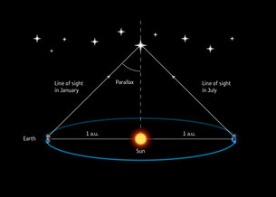 Stellar parallax
The nearer a star is to the Sun, the larger its parallax, and thus the parallax measured for a star can be used to determine its distance. In turn, the distance can be used to convert the apparent brightness of the star into its true brightness or ‘absolute luminosity’.
Gaia's first year of scientific observations (25 August 2015)

NEW HORIZONS TEAM SELECTS POTENTIAL KUIPER BELT FLYBY TARGET.

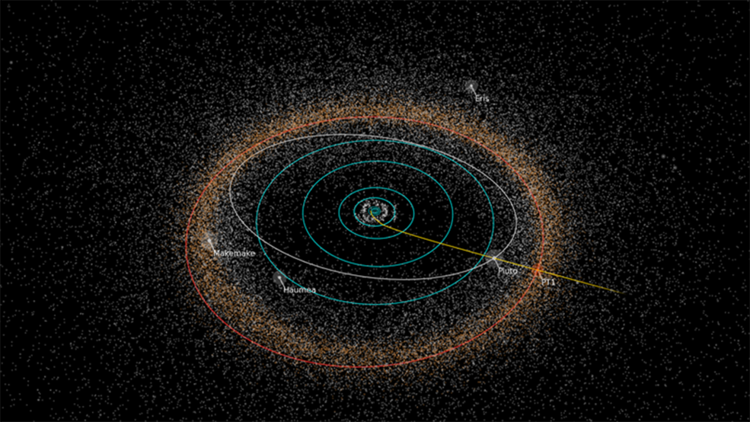Path of NASA's New Horizons spacecraft toward its next potential target, the Kuiper Belt object 2014 MU69, nicknamed "PT1" (for "Potential Target 1") by the New Horizons team. NASA must approve any New Horizons extended mission to explore a KBO. Credits: NASA/JHUAPL/SwRI/Alex Parker

NASA has selected the potential next destination for the New Horizons mission to visit after its historic July 14 flyby of the Pluto system. The destination is a small Kuiper Belt object (KBO) known as 2014 MU69 that orbits nearly a billion miles beyond Pluto. New Horizons was originally designed to fly beyond the Pluto system and explore additional Kuiper Belt objects. The spacecraft carries extra hydrazine fuel for a KBO flyby; its communications system is designed to work from far beyond Pluto; its power system is designed to operate for many more years; and its scientific instruments were designed to operate in light levels much lower than it will experience during the 2014 MU69 flyby. Unlike asteroids, KBOs have been heated only slightly by the Sun, and are thought to represent a well preserved, deep-freeze sample of what the outer solar system was like following its birth 4.6 billion years ago. New Horizons team selects potential Kuiper Belt flyby target (28 August 2015)

MAGNETICALLY DRIVEN RESONANCE HELPS HEAT THE SUN’S ATMOSPHERE.

Solar physicists have captured the first direct observational signatures of resonant absorption, thought to play an important role in solving the “coronal heating problem” which has defied explanation for over 70 years. Resonant absorption is a process where two different types of magnetically driven waves resonate, strengthening one of them. In particular this research looked at a type of magnetic waves known as Alfvénic waves which can propagate through a prominence (a filamentary structure of cool, dense gas floating in the corona). Here, for the first time, researchers were able to directly observe resonant absorption between transverse waves and torsional waves, leading to a turbulent flow which heats the prominence. Hinode observed the transverse motion and IRIS observed the torsional motion; these results would not have been possible without both satellites.This new information can help explain how the solar corona reaches temperatures of 1,000,000 degrees Celsius; the so called “coronal heating problem.”
Magnetically driven resonance helps heat the Sun’s atmosphere (24 August 2015)
AGE OF DEEP-SPACE EXPLORATION WITH CUBESATS HERALDED.
In what scientists say signals a paradigm shift in interplanetary science, NASA has selected a shoebox-size mission to search for water ice and other resources from above the surface of the moon.

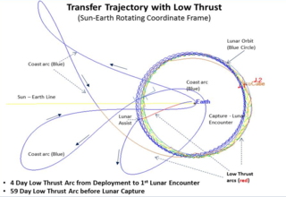
Getting to the moon will require that the Lunar IceCube take a circuitous route that uses the gravity of the sun, Earth and moon. Credits: NASA/Dave Folta

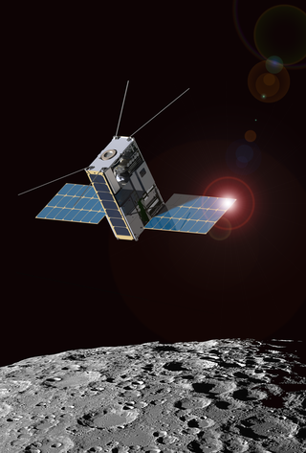
Morehead State University and Goddard are partnering to create the Lunar IceCube mission shown in this artist’s rendition. Credits: Morehead State University
In what scientists say signals a paradigm shift in interplanetary science, NASA has selected a shoebox-size mission to search for water ice and other resources from above the surface of the moon. Called Lunar IceCube, the mission is one of several public-private partnerships chosen under NASA’s Next Space Technologies for Exploration Partnerships (NextSTEP) Broad Agency Announcement for the development of advanced exploration systems. Among the first small satellites to explore deep space, Lunar IceCube will help lay a foundation for future small-scale planetary missions, mission scientists said. In addition to providing useful scientific data, Lunar IceCube will help inform NASA’s strategy for sending humans farther into the solar system. The ability to search for useful assets can potentially enable astronauts to manufacture fuel and other provisions needed to sustain a crew for a journey to Mars, reducing the amount of fuel and weight that NASA would need to transport from Earth. Lunar IceCube to take on big mission from small package (4 August 2015)

ESO AND ESA DIRECTORS GENERAL SIGN COOPERATION AGREEMENT.

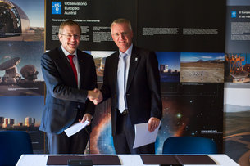
A cooperation agreement was signed at ESO’s offices in Santiago, Chile

On 20 August 2015 the Director General of ESO, Tim de Zeeuw, and the Director General of ESA, Johann-Dietrich Woerner, signed a cooperation agreement between the two organisations at ESO’s offices in Santiago, Chile. There is considerable overlap of interests between ESO, pre-eminent in ground-based astronomy, and ESA, Europe’s leader in space research and technology. The new agreement provides a framework for future close cooperation and exchange of information in many areas, including technology and scientific research. ESO and ESA Directors General sign cooperation agreement (24 August 2015)

LINKS TO OTHER SPACE AND ASTRONOMY NEWS PUBLISHED IN AUGUST 2015
ASTEROIDS
Cameras delivered for OSIRIS-REx mission as launch prep continues (24 August 2015) The first U.S. mission to return samples of an asteroid to Earth is another step closer to its fall 2016 launch, with the delivery of three cameras that will image and map the giant space rock.
ASTRONOMY
Northrop Grumman delivers telescope structure for James Webb Space Telescope (26 August 2015) Northrop Grumman Corporation delivered on schedule the telescope structure for NASA's James Webb Space Telescope Aug. 24 to Goddard Space Flight Center in Greenbelt, Maryland, paving the way for the integration of the 18 hexagonal mirrors that will help scientists observe the formation of the first stars and galaxies over 13.5 billion years ago.
ASTROPHYSICS
Lab experiment mimics early-stage planetary formation process (3 August 2015) Physicists have directly observed, for the first time, how highly charged dust-sized particles attract and capture others to build up clusters particle by particle.
Lost lithium destroyed by ancient stars (5 August 2015) Lithium, the lightest metal, used in batteries and mood-stabilising drugs, is rarer than it should be.
Gravitational constant appears universally constant, pulsar study suggests (6 August 2015) Gravity, one of the four fundamental forces of nature, appears reassuringly constant across the Universe, according to a decades-long study of a distant pulsar.
Searching for life in the Alpha Centauri system (6 August 2015) A new approach to searching for life on other planets: An international team has discovered that biopigments of plants, so-called biological photosynthetic pigments, leave behind unique traces in the light they reflect.
MicroBooNE experiment sees first cosmic muons (12 August 2015)
A school bus-sized detector packed with 170 tons of liquid argon has seen its first particle footprints.
Antarctic detector confirms observation of cosmic neutrinos (20 August 2015)
A group of researchers using a massive, National Science Foundation (NSF)-funded instrument buried deep in the ice at the geographic South Pole have announced a new observation of high-energy neutrinos, confirming they found particles from beyond our solar system--and beyond our galaxy.
A new approach towards solving mysteries of the interstellar medium (21 August 2015)
It is one of the most intriguing questions in astrochemistry: the mystery of the diffuse interstellar bands (DIBs), a collection of about 400 absorption bands that show up in spectra of light that reaches the earth after having traversed the interstellar medium.
Tiny drops of “perfect” fluid that existed in the early universe (31 August 2015)
Smashing large atomic nuclei, containing protons and neutrons, together at close to the speed of light re-creates the conditions of the very early universe.

BLACK HOLES
Oxymoronic black hole provides clues to growth (11 August 2015)
Astronomers using NASA’s Chandra X-ray Observatory and the 6.5-meter Clay Telescope in Chile have identified the smallest supermassive black hole ever detected in the centre of a galaxy.

DARK MATTER

Dark Energy Survey finds more celestial neighbours (17 August 2015)
Scientists on the Dark Energy Survey, using one of the world's most powerful digital cameras, have discovered eight more faint celestial objects hovering near our Milky Way galaxy.

Detection of gamma rays from a newly discovered dwarf galaxy may point to dark matter
(18 August 2015)
A newly discovered dwarf galaxy orbiting our own Milky Way has offered up a surprise — it appears to be radiating gamma rays, according to an analysis by physicists at Carnegie Mellon, Brown, and Cambridge universities.
No one knows exactly what dark matter is, but it is thought to account for around 80 percent of the matter in the universe. Scientists know that dark matter exists because it exerts gravitational effects on visible matter, which explains the observed rotation of galaxies and galaxy clusters as well as fluctuations in the cosmic microwave background.
“The gravitational detection of dark matter tells you very little about the particle behaviour of the dark matter,” said Matthew Walker, assistant professor of physics and a member of CMU’s McWilliams Center for Cosmology. “But now we may have a non-gravitational detection that shows dark matter behaving like a particle, which is a holy grail of sorts.”
A leading theory suggests that dark matter particles are WIMPs — Weakly Interacting Massive Particles. When pairs of WIMPs meet, they annihilate one another, giving off high-energy gamma rays. If that’s true, then there should be a lot of gamma rays emanating from places where WIMPs are thought to be plentiful, like the dense centres of galaxies. The trouble is, the high-energy rays also originate from many other sources, including black holes and pulsars, which makes it difficult to untangle a dark matter signal from the background noise. That’s why dwarf galaxies are important in the hunt for the dark matter particle. Dwarfs are thought to lack other gamma-ray-producing sources, so a gamma ray flux from a dwarf galaxy would make a very strong case for dark matter.
http://arxiv.org/pdf/1503.02320v1.pdf
A detector shines in search for dark matter (20 August 2015)
Results of the XENON100 experiment are a bright spot in the search for dark matter.

DARK ENERGY
Experiment attempts to snare a dark energy ‘chameleon’ (20 August 2015)
If dark energy is hiding in our midst in the form of hypothetical particles called “chameleons,” Holger Müller and his team at UC Berkeley plan to flush them out.

EARTH

Equatorial regions are prone to disruptive space weather, new study finds (17 August 2015)
Extreme space weather has long been seen as a threat to electrical grids in high-latitude regions of the northern and southern hemispheres.

NASA begins to build satellite mission to improve hurricane forecasting (19 August 2015)
Ten years after Hurricane Katrina formed in the Atlantic, construction of NASA’s next-generation hurricane-observing satellite mission now is underway in Texas.

EXOPLANETS
Lawrence Livermore scientists discover new young planet (13 August 2015)
For the first time, Lawrence Livermore scientists as part of an international team, have discovered the most Jupiter-like planet ever seen in a young star system, lending clues to understanding how planets formed around our sun.

Methane enshrouds nearby Jupiter-like exoplanet (13 August 2015)
The Gemini Planet Imager has discovered and photographed its first planet, a methane-enshrouded gas giant much like Jupiter that may hold the key to understanding how large planets form in the swirling accretion disks around stars.

GALAXIES
Ghostly remnants of galaxy interactions uncovered in a nearby galaxy group (4 August 2015) Astronomers using the Subaru Telescope's Hyper Suprime-Cam prime-focus camera recently observed the nearby large spiral galaxy M81, together with its two brightest neighbours, M82 and NGC3077.
Distant protogalaxy connected to the cosmic web (5 August 2015)
A team of astronomers led by Caltech has discovered a giant swirling disk of gas 10 billion light-years away—a galaxy-in-the-making that is actively being fed cool primordial gas tracing back to the Big Bang.
Celestial firework marks nearest galaxy collision (16 August 2015)
A spectacular galaxy collision has been discovered lurking behind the Milky Way.

Chandra data suggest giant collision triggered “radio phoenix” (26 August 2015)
Astronomers have found evidence for a faded electron cloud “coming back to life,” much like the mythical phoenix, after two galaxy clusters collided.
Unravelling the history of galaxies for the first time (27 August 2015)
A team of international scientists, led by astronomers from Cardiff University’s School of Physics and Astronomy, has shown for the first time that galaxies can change their structure over the course of their lifetime. http://mnras.oxfordjournals.org/content/452/4/3489.full
Discovering dust-obscured active galaxies as they grow (26 August 2015)
A group of researchers from Ehime University, Princeton University, and the National Astronomical Observatory of Japan (NAOJ) among others has performed an extensive search for Dust Obscured Galaxies (DOGs) using data obtained from the Subaru Strategic Program with Hyper Suprime-Cam (HSC).

HUMANS IN SPACE

Spaceflight may increase susceptibility to inflammatory bowel disease (5 August 2015)
When mice were subjected to simulated spaceflight conditions, the balance of bacteria and the function of immune cells in the gut changed, leading to increased bowel inflammation. http://www.fasebj.org/content/early/2015/04/15/fj.15-271700.abstract

60 days and 60 nights . . . in bed (28 August 2015)
On 9 September, the first of 12 men will go to bed for 60 days as part of important research into stopping the wasting effects that spaceflight has on the human body.

INTERNATIONAL SPACE STATION
Expedition 44 crew members sample leafy greens grown on space station (7 August 2015)
Fresh food grown in the microgravity environment of space officially is on the menu for the first time for NASA astronauts on the International Space Station.
Student satellite soon to take off to International Space Station (14 August 2015)
A very special week is about to begin for approximately 30 students from Aalborg University, in Denmark, as their satellite - AAUSAT5 - waits to be launched to the International Space Station (ISS) on Wednesday 19 August.
Technology CubeSat hitch-hiker on today's HTV launch (19 August 2015)
Today’s HTV supply launch from Japan to the International Space Station also marks the arrival in orbit of one of ESA’s smallest missions yet – a CubeSat which will test miniaturised technologies for space, set to be followed by many more in coming years.

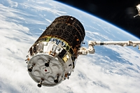
HTV4 (Credit: JAXA/NASA)

The H-II Transfer Vehicle (HTV) "KOUNOTORI", developed and built in Japan, is an unmanned cargo transfer spacecraft that delivers supplies to the International Space Station (ISS). Its first, "technical demonstration flight" was launched in September, 2009. HTV is scheduled to launch about once a year to contribute to the ISS operations.
The H-II Transfer Vehicle (HTV), developed and built in Japan, is an unmanned cargo transfer spacecraft that delivers supplies to the International Space Station (ISS).
The HTV is launched from the Tanegashima Space Center aboard an H-IIB launch vehicle with up to 6,000kg of supplies. When the HTV approaches close to the ISS, the Space Station Remote Manipulator System (SSRMS), known as "Canadarm2," grapples the HTV and berth it to the ISS. After the supplies, such as food, clothes and a variety of experiment equipment, are unloaded, the HTV will then be loaded with waste materials, including used experiment equipment or used clothes. The HTV will then undock and separate from the ISS and reenter the atmosphere. While the HTV is berthed to the ISS, the ISS crew will be able to enter and remove the supplies from the HTV Pressurized Logistics Carrier.
Latest series of National Lab investigations berthed to the International Space Station
(24 August 2015) The most recent series of payloads sponsored by the Center for the Advancement of Science in Space (CASIS) successfully berthed to the International Space Station (ISS) onboard the Japanese H-II Transfer Vehicle (HTV-5).
Soyuz move sets stage for arrival of new space station crew (25 August 2015) Half of the residents of the International Space Station will take a spin around their orbital neighbourhood in the Soyuz TMA-16M spacecraft on Friday, Aug. 28.
Launch of next International Space Station crew
(26 August 2015) The next three crew members bound for the International Space Station are set to launch to the orbital outpost Wednesday, Sept.
Astronaut Andreas to try sub-millimetre precision tasks on Earth from orbit (27 August 2015)
Early September will see the very first force-feedback-based teleoperation of a rover-based robotic arm system on Earth from the International Space Station, orbiting 400 km above our heads.

MARS
Salt flat indicates some of the last vestiges of surface water on Mars (7 August 2015)
Mars turned cold and dry long ago, but researchers at the University of Colorado Boulder have discovered evidence of an ancient lake that likely represents some of the last potentially habitable surface water ever to exist on the Red Planet.

MISCELLANEOUS
Poland becomes ESO’s fifteenth Member State (5 August 2015)
Poland has now completed the ratification of its membership of ESO and becomes the organisation’s fifteenth Member State.
Citizens in Space announces payload manifest for first space mission (13 August 2015)
Citizens in Space, a project of the United States Rocket Academy, has announced a list of 10 experiments selected for its first research mission on the XCOR Aerospace Lynx spacecraft.

MOON
LADEE spacecraft finds neon in lunar atmosphere (17 August 2015)
While scientists have speculated on the presence of neon in the lunar atmosphere for decades, NASA's Lunar Atmosphere and Dust Environment Explorer (LADEE) spacecraft has confirmed its existence for the first time.
Research may solve lunar fire fountain mystery (24 August 2015)
Tiny beads of volcanic glass found on the lunar surface during the Apollo missions are a sign that fire fountain eruptions took place on the Moon’s surface.

QUASARS
Nearest quasar is powered by a double black hole (27 August 2015)
Astronomers using NASA's Hubble Space Telescope have found that Markarian 231 (Mrk 231), the nearest galaxy to Earth that hosts a quasar, is powered by two central black holes furiously whirling about each other.

SATURN AND MOONS
Riddle of planetary rings solved (5 August 2015)
In a breakthrough study, an international team of scientists, including Professor Nikolai Brilliantov from the University of Leicester, has solved an age-old scientific riddle by discovering that planetary rings, such as those orbiting Saturn, have a universally similar particle distribution. What is surprising is that the relative abundance of particles of different sizes follows, with a high accuracy, a beautiful mathematical law ‘of inverse cubes’. That is, the abundance of 2 metre-size particles is 8 times smaller than the abundance of 1 metre-size particles, the abundance of 3 metre-size particles is 27 times smaller and so on. This holds true up to the size of about 10 metres, then follows an abrupt drop in the abundance of particles. The reason for this drastic drop, as well as the nature of the amazing inverse cubes law, has remained a riddle until now. We have finally resolved the riddle of particle size distribution. In particular, our study shows that the observed distribution is not peculiar for Saturn's rings, but has a universal character. In other words, it is generic for all planetary rings which have particles to have a similar nature.

Origin of Saturn’s F ring and its shepherd satellites revealed (19 August 2015) Hyodo Ryuki, a second-year student in the Doctoral Program, and Professor Ohtsuki Keiji of the Graduate School of Science at Kobe University have revealed that Saturn’s F ring and its shepherd satellites are natural outcome of the final stage of formation of Saturn’s satellite system.

SOLAR SYSTEM
Solar system formation don’t mean a thing without that spin (18 August 2015)
New work from Carnegie's Alan Boss and Sandra Keiser provides surprising new details about the trigger that may have started the earliest phases of planet formation in our solar system.

STARS AND STAR CLUSTERS
Super star takes on black holes in jet contest (4 August 2015)
A super-dense star formed in the aftermath of a supernova explosion is shooting out powerful jets of material into space, research suggests.
Dying star suffers ‘irregular heartbeats (26 August 2015)
Some dying stars suffer from ‘irregular heartbeats’, research led by astronomers at the University of Warwick has discovered.

SUB ORBITAL SPACE

SUN
New tools for predicting arrival, impact of solar storms (11 August 2015)
When the sun hurls a billion tons of high-energy particles and magnetic fields into space at speeds of more than a million miles per hour and the "space weather" conditions are right, the resulting geomagnetic storm at Earth can wreak havoc on communication and navigation systems, electrical power grids, and pose radiation hazards to astronauts and airline passengers and crew.

SUPERNOVA
Hubble finds supernovae in 'wrong place at wrong time' (13 August 2015)
Scientists have been fascinated by a series of unusual exploding stars-outcasts beyond the typical cosy confines of their galaxies.

TECHNOLOGY AND TECHNOLOGY TRANSFER
Trusty, not rusty, pipelines owe a debt to space (12 August 2015)
When a Dutch company working on soil pollution teamed up with ESA to build a better, bacteria-based air filter for space, they also created the foundation for a new way of keeping iron pipelines from corroding in the ground.
First sunshield layer completed for NASA's James Webb Space Telescope (12 August 2015)
The first of the five sunshield layers that will make it possible for NASA's James Webb Space Telescope to image the formation of stars and galaxies created more than 13.5 billion years ago, was delivered to Northrop Grumman Corporation's Space Park facility April 24.
NASA awards grants for technologies that could transform space exploration (14 August 2015)
NASA has selected eight university-led proposals to study innovative, early stage technologies that will address high-priority needs of America's space program.

University of Maryland researchers building a better battery for space exploration (18 August 2015)
A research team from the University of Maryland Energy Research Center (UMERC) has been awarded $1 million in NASA funding for its Garnet Electrolyte Based Safe, Lithium-Sulphur Energy Storage project, a game-changing battery technology that could potentially power future space missions.

UNIVERSE

5 billion light years across: the largest feature in the universe (5 August 2015)
A Hungarian-US team of astronomers have found what appears to be the largest feature in the observable universe: a ring of nine gamma ray bursts – and hence galaxies - 5 billion light years across.
Milky Way-like galaxies may have existed in the early universe (5 August 2015)
A new, large-scale computer simulation has shown for the first time that large disk galaxies, much like our own Milky Way, may have existed in the early days of the universe.
Hubble finds evidence of galaxy star birth regulated by black-hole fountain (6 August 2015) Astronomers have uncovered a unique process for how the universe's largest elliptical galaxies continue making stars long after their peak years of star birth.
Charting the slow death of the universe (10 August 2015)
An international team of astronomers studying more than 200 000 galaxies has measured the energy generated within a large portion of space more precisely than ever before.

Pat Williams. August 2015

